Clearview Minor Hockey
ONLINE REGISTRATION HELP
FIRST TIME USER TO ONLINE REGISTRATION
FAMILY ACCOUNT SET UP
As a first time user to the online registration website, you need to create an account to register players. This account is a “family” account; you only need ONE account to register multiple family members
To create an account, you would click on the “CLICK HERE TO CREATE AN ACCOUNT” link.

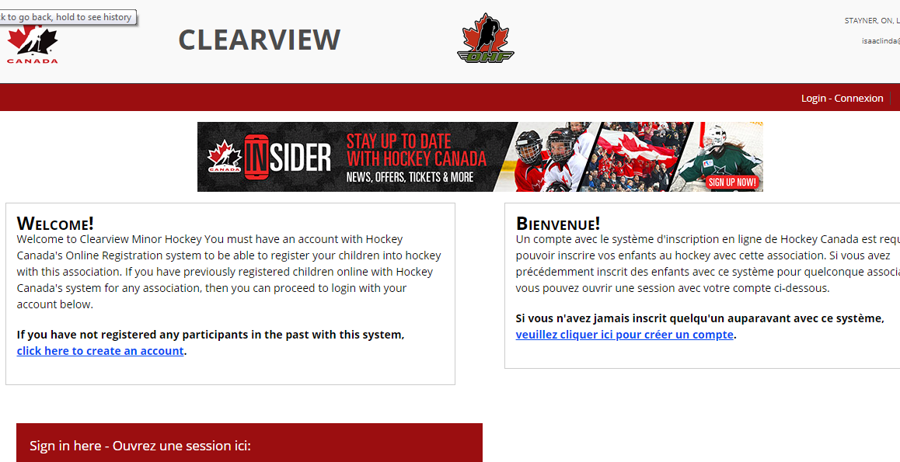

- Select preferred language and read the provided information and agree to terms.

- The next step is to provide some account information. This includes name, address, and contact information. This is personal information of the account holder. THIS IS NOT THE INFORMATION OF THE PLAYER. Once the account is created, the user is brought to the main home page where they can see their shopping cart and previous registrations, access account options and register a player.

RETURNING USER TO ONLINE REGISTRATION

FAMILY LOGIN (used online registration previously)

- If you registered online last season, your Hockey Canada account remains the same. Your login account is your email address. Should you fail to remember login, please try all email addresses you may have had in the previous year before setting up a new account.
- Forgotten passwords can be retrieved by clicking “Forgot Your Password”. A new password will be emailed to your email address that you used to login. If you do not receive an email within 24 hours, please contact the CMH at clearviewmhregistration@outlook.com

- Please review name & address on account. Upon successful registration, a receipt/invoice will be issued to the name & address on this account. If necessary, edit the family information. THIS DOES NOT UPDATE THE PLAYERS RESIDENTIAL ADDRESS IN HOCKEY CANADA.

FINDING YOUR CHILD – RETURNING MEMBERS

- Click on “Register a New Participant”. To register your child, you will be required to input the child’s first name, last name, date of birth, and gender. You may also use your child’s Hockey Canada registration number if known. If your child played hockey in any prior season, they will be in the Hockey Canada system. If having difficulties locating your child’s information, please try a number of variations, as your input must be an exact match to the Hockey Canada record. Common types of errors:
- Name variations:
- Benjamin vs Ben
- Middle name used instead of legal first name (and vice versa)
- O’Toole vs O Toole
- McDonald vs Mc Donald
- Date of Birth errors:
- Month and day switched around
- Wrong birth year

After you have registered your child you may contact the CMH Registrar to have any changes made your child’s profile. Legal documentation may be requested

If after trying the above and you are still not successful, please contact the CHM Registrar for assistance. IF YOUR CHILD PLAYED WITH Creemore or Stayner IN THE PREVIOUS SEASON, THEY ARE IN THE SYSTEM, PLEASE DO NOT CREATE A DUPLICATE RECORD.
2. When you locate the player you wish to register, click “Register Now”. If you see “Unavailable” contact the Registrar.

ONLINE PAYMENT/CHECK OUT

- Online registration payments must be done with CREDIT CARD ONLY. A receipt/invoice will be emailed to you upon successful completion of the credit card transaction.

Lock out Errors: If you experience a lock out error during your online payment portion, please wait one hour for the system to reset and try again.

